Date: December 09, 2015

REQUEST FOR QUOTATION
RFQ Nº UNFPA /RFQ_EECARO/2015/05

Dear Sir/Madam,

UNFPA hereby solicits a quotation for the following service:

Procurement, installation and configuration of Audio Visual (AV) equipment
UNFPA requires the provision of procurement for new AV equipment and maintenance of existing equipment. The selected contractor will deliver and install the equipment, will train UNFPA staff on how to operate the equipment and will provide yearly service and maintenance.

This Request for Quotation is open to all legally-constituted companies that can provide the requested products & services in Annex II and have legal capacity to deliver in the country, or through an authorized representative.

- About UNFPA
UNFPA, the United Nations Population Fund (UNFPA), is an international development agency that works to deliver a world where every pregnancy is wanted, every child birth is safe and every young person’s potential is fulfilled.

UNFPA is the lead UN agency that expands the possibilities for women and young people to lead healthy sexual and reproductive lives. To read more about UNFPA, please go to: UNFPA about us

II – Service Requirements/Terms of Reference (ToR)

Objectives and scope of the Services

The UNFPA EECARO intends to equip several rooms of its regional office in Istanbul, Turkey with audio visual systems to update some of the existing equipment. The Agency is looking for a qualified company to contract for purchase of new AV equipment and maintenance of existing one. The selected contractor will deliver and install the equipment, will train UNFPA staff on how to operate the equipment and will provide yearly service and maintenance.
The use of AV facilities is intended to provide a framework for meeting activities and events of a wide-ranging scope and nature. The requirements for the AV facilities are therefore first and foremost a high degree of flexibility and future-proofing. In addition, all systems and installations should be based on equipment of very high quality so as to achieve superlative picture and sound quality combined with a simple and intuitive user interface. The following rooms will be updated with new equipment:
- Small corner meeting room on18th floor
- Large meeting room on 18th floor

- Questions
Questions or requests for further clarifications should be submitted in writing to the contact person below:

Name of contact person at UNFPA: | Esra Kahvecioglu
Tel Nº: | +90 212 705 36 65
Email address of contact person: | kahvecioglu@unfpa.org

The deadline for submission of questions is [Friday, November 17th 2015 at 5:00 PM Istanbul Time]. Questions will be answered in writing and shared with all parties as soon as possible after this deadline.

- Content of quotations
Quotations should be submitted in a single e-mail whenever possible, depending on file size. Quotations must contain:

- Technical proposal, in response to the requirements outlined in the service requirements / TORs.
- Price quotation, to be submitted strictly in accordance with the price quotation form.

Both parts of the quotation must be signed by the bidding company’s relevant authority and submitted in PDF format.

- Instructions for submission
Proposals should be prepared based on the guidelines set forth in Section IV above, along with a properly filled out and signed price quotation form, are to be sent by e-mail to the contact person indicated below no later than : [Wednesday, December 23th 2015 at 5:00 PM Istanbul Time].

Name of contact person at UNFPA: | Esra Kahvecioglu
Email address of contact person: | eecaro.procurement@unfpa.org

Please note the following guidelines for electronic submissions:
- The following reference must be included in the email subject line: RFQ Nº UNFPA /RFQ_EECARO/2015/05 Procurement, installation and configuration of AV Equipment. Proposals that do not contain the correct email subject line may be overlooked by the procurement officer and therefore not considered.
- The total e-mail size may not exceed 20 MB (including e-mail body, encoded attachments and headers). Where the technical details are in large electronic files, it is recommended that these be sent separately before the deadline.

- Overview of Evaluation Process
Quotations will be evaluated based on the technical proposal and the total cost of the services (price quote).

The evaluation will be carried out in a two-step process by an ad-hoc evaluation panel. Technical proposals will be evaluated for technical compliance prior to the comparison of price quotes.

- Award Criteria
UNFPA shall award a Professional Service Contract on a fixed-cost basis with duration of 15 (fifteen) days to the lowest-priced technically acceptable offer.

- Right to Vary Requirements at Time of Award
UNFPA reserves the right at the time of award of contract to increase or decrease by up to 20% the volume of services specified in this RFQ without any change in unit prices or other terms and conditions.

- Payment Terms
UNFPA payment terms are net 30 days upon receipt of invoice and delivery/acceptance of the milestone deliverables linked to payment as specified in the contract.

- Fraud and Corruption
UNFPA is committed to preventing, identifying, and addressing all acts of fraud against UNFPA, as well as against third parties involved in UNFPA activities. UNFPA’s Policy regarding fraud and corruption is available here: Fraud Policy. Submission of a proposal implies that the Bidder is aware of this policy.

Suppliers, their subsidiaries, agents, intermediaries and principals must cooperate with the Office of Audit and Investigation Services of UNFPA as well as with any other oversight entity authorized by the Executive Director of UNFPA and with the UNFPA Ethics Advisor as and when required. Such cooperation shall include, but not be limited to, the following: access to all employees, representatives, agents and assignees of the vendor; as well as production of all documents requested, including financial records. Failure to fully cooperate with investigations will be considered sufficient grounds to allow UNFPA to repudiate and terminate the contract, and to debar and remove the supplier from UNFPA’s list of registered suppliers.

A confidential Anti-Fraud Hotline is available to any Bidder to report suspicious fraudulent activities at UNFPA Investigation Hotline.

- Zero Tolerance
UNFPA has adopted a zero-tolerance policy on gifts and hospitality. Suppliers are therefore requested not to send gifts or offer hospitality to UNFPA personnel. Further details on this policy are available here: Zero Tolerance Policy.

- RFQ Protest
Bidder(s) perceiving that they have been unjustly treated in connection with the solicitation or award of a contract may submit a complaint directly to the Chief, Procurement Services Branch at procurement@unfpa.org.

Bidder(s) perceiving that they have been unjustly or unfairly treated in connection with a solicitation, evaluation, or award of a contract may submit a complaint to the UNFPA Head of the Business Unit [Mr. Heimo Laakkonen, Regional Director] at [laakkonen@unfpa.org]. Should the supplier be unsatisfied with the reply provided by the UNFPA Head of the Business Unit, the supplier may contact the Chief, Procurement Services Branch at procurement@unfpa.org.

- Disclaimer
Should any of the links in this RFQ document be unavailable or inaccessible for any reason, bidders can contact the Procurement Officer in charge of the procurement to request for them to share a PDF version of such document(s).

PRICE Quotation Form

Name of Bidder:
Date of the quotation: | 01/12/2015
Request for quotation Nº: | UNFPA /RFQ_EECARO/2015/05
Currency of quotation: | USD
Delivery charges based on the following 2010 Incoterm: | N/A
Validity of quotation:
(The quotation shall be valid for a period of at least 3 months after the submission deadline.)

- Quoted rates must be exclusive of all taxes, since UNFPA is exempt from taxes.

Example Price Schedule below:

Item | Description | Number items | Total
1 | 65” HD TV | 2
2 | Cardioid bidirectional wired microphones | 6
3 | Digital Automatic Mixer | 1
4 | Gooseneck Wireless Transmitter | 14
5 | Wireless Handheld Transmitter: | 2
6 | Wireless Transceiver | 2
7 | Audio Network Interface | 1
8 | Charging Station: | 1
Total Out of Pocket Expenses |  |  |  | $$
Total Contract Price  (Professional Fees + Out of Pocket Expenses) |  |  |  | $$

Vendor’s Comments:

I hereby certify that the company mentioned above, which I am duly authorized to sign for, has reviewed RFQ UNFPA /RFQ_EECARO/2015/05 including all annexes, amendments to the RFQ document (if applicable) and the responses provided by UNFPA on clarification questions from the prospective service providers. Further, the company accepts the General Conditions of Contract for UNFPA and we will abide by this quotation until it expires.
 | Click here to enter a date.
Name and title | Date and place

ANNEX I:
General Conditions of Contracts:
De Minimis Contracts

This Request for Quotation is subject to UNFPA’s General Conditions of Contract: De Minimis Contracts, which are available in: English, Spanish and French

ANNEX II:
Technical Specifications and Scope of Work
1
Purchase, installation and configuration of AV equipment for the UNFPA EECARO Office
1.0 General remarks
The UNFPA EECARO intends to equip several rooms of its regional office in Istanbul, Turkey with audio visual systems to update some of the existing equipment. The Agency is looking for a qualified company to contract for purchase of new AV equipment and maintenance of existing one. The selected contractor will deliver and install the equipment, will train UNFPA staff on how to operate the equipment and will provide yearly service and maintenance.
The use of AV facilities is intended to provide a framework for meeting activities and events of a wide-ranging scope and nature. The requirements for the AV facilities are therefore first and foremost a high degree of flexibility and future-proofing. In addition, all systems and installations should be based on equipment of very high quality so as to achieve superlative picture and sound quality combined with a simple and intuitive user interface.
The following rooms will be updated with new equipment:
- Small corner meeting room on18th floor
- Large meeting room on 18th floor
2.0 Small Corner meeting room 18th floor
The room is intended to serve as a standalone conference room. The room should be equipped with following. Proposed offer should include all equipment cost, cabling, installation, configuration, setup and training.
− 65” wall mounted LED-backlit HDTV
− Sound system with 6 wired table microphones and mixer
2.1 HD TV screen
A 65” TV screen will be mounted into the wall from 100 cm above the floor. The size of the screen will make it possible to show several images at a time and/or presentations requiring high resolution. The TV screen shall meet the following specifications:
Panel specifications
Screen Size: 65" (64.5” diagonal)
Resolution: 3840 x 2160 or better
Display Type: UHD LED with Edge Backlighting
Dimensions / weight
TV without Stand (WxHxD): 140 x 90 x 6 cm or smaller
TV without Stand weight: Max. 35 kg
Video
Dynamic Color Enhancer: Must be supported
1:1 Pixel Matching: HDMI, Component, RF: 1080i, 1080p, 720p
Audio
Speaker System: 2 Channel Speaker System
Audio Output Power: 35W or higher
Mono/Stereo/Dual (MTS/SAP): Must be supported
Dolby Digital Decoder: Must be supported
Av inputs/outputs
RF In (Antenna/Cable): Minimum 1
Component Video In(Y, Pb, Pr + Audio): Minimum 1
HDMI: Minimum 3
USB 3.0: Minimum 3
Digital Audio Out (Optical): 1
LAN: 1
RS-232 (mini jack): 1
Power
Energy star certification: Requested
Power supply (v): 100v - 240v, 50/60 Hz
Standby power consumption: Must be under 0.3W
Accessories:
Remote controller,
Wall mount kit
European style power cable
User manual
Warranty: Minimum 1 Year Parts & Labor
2.2 Sound system
The sound system shall meet the following specifications:
- Proposed system should be compatible and must be integrated to existing Audio Visual system. List of the equipment which is already installed can be found in Annex.1.

2.2.1 6 (six) cardioid bidirectional wired microphones:
- The microphones shall be a surface mounted, black electret condenser microphone with three cardioid polar pattern elements, each with individual channel output (Three element 90-0-90 mic, adjustable to 120-120-120 degrees).
- The microphone shall include a logic enabled, bi-colored status indicator ring and programmable mute switch.
- The microphone shall be resistant to RF interference from portable mobile and handheld devices.
- Sensitivity -46 dBV/Pa
- Frequency response 50 Hz to 20 kHz
- Directivity 0°/180° > 20 dB (1 kHz)
- Equivalent noise 20 dBA (SPL)
- Maximum sound pressure level 125 dB (THD<3%)
- Optional: earphone output, Earphone output 10 mW, Earphone load impedance >16 Ohm

2.2.2 Digital Automatic Mixer:
- Mixer should support automatic mixing and reduced background noise through dynamic channel gating and attenuation
- DB25 or logic-enabled block connectors each with 8 inputs
- Per channel direct outputs for use as an insert to a mixing console or recording
- Mix A and B outputs with selectable mic or line level connect to a sound reinforcement system, mixing console, or recording device, Individual channel control for quick adjustment of gain, limiter, EQ, and solo/mute
- Should support browser-based control software for control, monitoring, routing and configuration
- Built-in telephone interface and speaker amplifier for standalone conferencing applications
- Should be compatible with existing Crestron control system
- Mixer to be installed in the meeting hall 2’s rack cabinet

Mixer Audio Performance
Conditions: Unless otherwise specified, all measurements are performed with a 20 Hz to 22 kHz
BW limit (no weighting)
Frequency Response: 20 Hz to 22 kHz ±1dB
Noise (EIN): -126 dBu, 22 kHz BW, max gain,Rs=150 Ω
THD+N: <0.02%
Dynamic Range: 100 dB (non A-weighted)
Crosstalk <-91 dB re 20 dBu @ 20 kHz channel to channel

Auto Mixer Parameters
Number of Open Microphones (NOM)
PA Adaptive Mode
First Mic Priority Mode
Last Mic Mode
Maximum # of Mics Mode
Ambient Level
Gate Threshold Adjust
Off Attenuation Adjust
Hold Time
Decay Rate

Microphone Input Configuration
Input Gain Adjust
Mic or Line Level
Phantom Power on/off
Echo Cancellation on/off
Noise Cancellation on/off
Filters
All Pass
Low Pass
High Pass
Notch
PEQ
Mute on/off
Chairman Override on/off
AGC on/off
Automatic Level Control on/off
Auto Gate/Manual gate
Adaptive Ambient on/off
Pre-AEC channel

Assignable Processing Blocks
Filters
- All pass
- Low pass
- High pass
- Low shelving
- High shelving
- Parametric EQ
- Notch
- CD Horn
Crossovers
- Bessel
- Butterworth
- Linkwitz-Riley

Delay; adjustable up to 250 ms

Line Inputs
Push-on mini-terminal block, balanced, bridging
Impedance: < 10 KΩ
Nominal Level: 0 dBu
Maximum Level: 20 dBu

For location of microphones other equipment, please see layout of corner room below
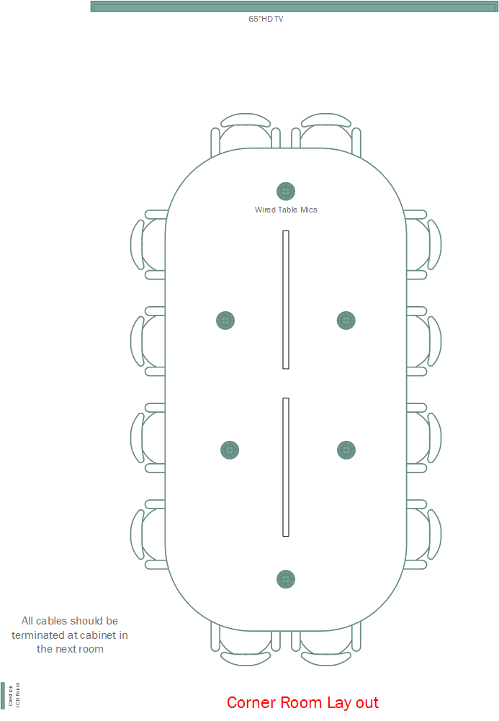

3.0 Large meeting room 18th floor
The room is intended to serve as a multi-function conference facility. It can be used either as a whole or as a three separated zone.
The room should be equipped with following:
− 65” wall mounted LED-backlit HDTV
− Sound system with 14 wireless microphones and mixer
3.1 HD TV screen
A 65” TV screen will be mounted into the wall from 100 cm above the floor. The size of the screen will make it possible to show several images at a time and/or presentations requiring high resolution. The TV screen shall meet the following specifications:
Panel specifications
Screen Size: 65" (64.5” diagonal)
Resolution: 3840 x 2160 or better
Display Type: UHD LED with Edge Backlighting
Dimensions / weight
TV without Stand (WxHxD): 140 x 90 x 6 cm or smaller
TV without Stand weight: Max. 35 kg
Video
Dynamic Color Enhancer: Must be supported
1:1 Pixel Matching: HDMI, Component, RF: 1080i, 1080p, 720p
Audio
Speaker System: 2 Channel Speaker System
Audio Output Power: 35W or higher
Mono/Stereo/Dual (MTS/SAP): Must be supported
Dolby Digital Decoder: Must be supported
Av inputs/outputs
RF In (Antenna/Cable): Minimum 1
Component Video In(Y, Pb, Pr + Audio): Minimum 1
HDMI: Minimum 3
USB 3.0: Minimum 3
Digital Audio Out (Optical): 1
LAN: 1
RS-232 (mini jack): 1
Power
Energy star certification: Requested
Power supply (v): 100v - 240v, 50/60 Hz
Standby power consumption: Must be under 0.3W
Accessories:
Remote controller,
Wall mount kit
European style power cable
User manual
Warranty: Minimum 1 Year Parts & Labor

3.2 Sound system
The sound system shall meet the following specifications:
- Proposed system should be compatible and must be integrated into existing Audio Visual system. List of the equipment which is already installed can be found in Annex.2.

3.2.1 14 (fourteen) Gooseneck Wireless Transmitter:
- Cardioid type, 10" (25.4 cm) with bi-color status indicator
- Bi-directional wireless should be supported
- Should have earphone output to enable listen to audio from a return channel for translation, cueing, or program material
- Should have programmable mute button to customize local or remote muting behavior per application, with options including push-to talk, push-to-mute, and external control
- AES 256-bit encryption for secure wireless transmission must be supported
- Wireless coverage should be minimum 50 meters
- Should warn by emitting beeping sound when range limit is exceeded
- Li-ion batteries should provide power up to 9 hours of continuous use and batteries should charge to full in 2 hours
- USB charging should be supported for “always on” usage

3.2.2 2 (two) Wireless Handheld Transmitter:

- AES 256-bit encryption for secure wireless transmission must be supported
- Wireless coverage should be minimum 50 meters
- Should warn by emitting beeping sound when range limit is exceeded
- Li-ion batteries should provide power up to 15 hours of continuous use and batteries should charge to full in 2 hours
- USB charging should be supported for “always on” usage

3.2.3 2 (two) Wireless Transceiver:
- Wall/ceiling mounting kit should be provided
- Should be connected to system over Ethernet cable (PoE compatible)
- Minimum 8 channels should be supported
- Bi-directional wireless should be supported to provide return channel audio to wireless transmitters and enables real time remote control of all wireless microphone settings
- Should automatically scan available spectrum, coordinate clean frequency assignments, and move channels away from unexpected interference
- AES 256-bit encryption for secure transmission must be supported
- Diagnostic LEDs should be available for easy visual reference to system activity and indicate power, wireless connection, and network audio status

3.2.4 1 (one) Audio Network Interface:

- Analog connections: 8 block connector channel outputs, with 2 block connector inputs
- System should enable to split big meeting room into three independent zone. Eacj zone should
- Four gigabit Ethernet port required for connection to the Access Point Transceiver and Networked Charging Stations, third party control systems, and corporate networks
- Ethernet connectivity should be able send audio and control signals over long cable runs of up to 300 feet or anywhere over a corporate network
- Power over Ethernet: At least one of the rear panel switch supplies power over Ethernet to the Access Point Transceiver for simplified installation
- Front panel controls: Mute or solo channels and set input/output levels should be easily done from the front panel
- Built-in telephone interface and speaker amplifier for standalone conferencing applications.
- Software control: Access to control system from a networked computer for input/output levels and port configuration should be possible

- 1 (one) Charging Station:
- Minimum 8 port charging station compatible with offered wireless transmitters
- Remote charge status monitoring through Ethernet should be possible
- Overcharge protection should exist to avoid battery damage and to extend battery life cycle

For location of microphones other equipment, please see layout of big meeting room below

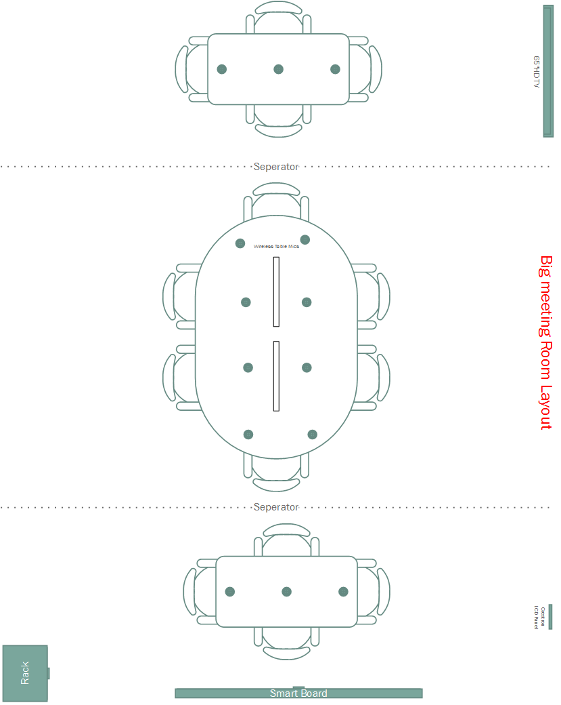

Annex.1 Corner Meeting Room Existing AUDIO/VIDEO & AUTOMATION SYSTEM

NO | BRAND | MODEL | DESCRIPTION | QTY | UNIT

1 | SHARP | PG-D3050W | 16:10 DLP 3000 ANS PROJECTION | 1 | pcs
2 |  |  | PROJECTION CEILING MOUNT BRACKET | 1 | pcs
3 | DRAPER | TARGA | 99"/252 cm 119 x 221 MOTORIZED SCREEN | 1 | pcs
4 | SONY |  | BLU-RAY DVD PLAYER | 1 | pcs
5 | EXTRON | CrossPoint Ultra 84 HVA | 8x4 Ultra-Wideband Matrix Switcher with ADSPTM for RGB and Stereo Audio | 1 | pcs
6 | BEYERDYNAMIC | SHM 22 H SW SET | Miniature condenser gooseneck mic, black, for hanging ceiling mounting, with cable 8 m (26 ft.), incl. pre-amplifier CV 15 PV-N(C)-R | 4 | pcs
7 | BEYERDYNAMIC | SHM 22 H SW SET | Acoustic Echo Canceling MICROPHONE | 1 | pcs
8 | AVUNO | sC6 | 2-WAY 6" CEILING SPEAKER | 6 | pcs
9 | BIAMP | NEXIA TC | 8 wide-band TrueSoundTM AEC inputs, 2 mic/line inputs, 4 mic/line outputs, & telephone interface. DSP for teleconferencing applications. | 1 | pcs
10 | BIAMP | NEXIA VC | 8 wide-band TrueSoundTM AEC inputs, 2 mic/line inputs, 4 mic/line outputs, & codec interface. DSP for videoconferencing applications. | 1 | pcs
11 | BIAMP | CPA130 | Dual 65 watt/channel @ 4 ohms passively cooled amp | 1 | pcs
 | BIAMP | D60EQ | 60 watt amplifier, distribution autoformer, and 9-band graphic EQ (†) | 1 | pcs
12 | CRESTRON | AV2 | Economical Dual Bus Control System. 1 Z-Bus slot, optional CAGE2 card cage adds 3 Y-Bus slots. Built-in Power Supply | 1 | pcs
13 | CRESTRON | C2ENET-1 | Single Port 10/100BaseT Ethernet Card with e-Control®2 for ZBus Expansion Slot | 1 | pcs
14 | CRESTRON | DIN-2MC2 | DIN Rail Motor Control, 2 feeds, 2 channels | 1 | pcs
15 | CRESTRON | TPMC-8LB-T KIT | Isys i/O 8.4" Wall Mount Touchpanel Media Center, Black, Textured. Includes TPMC-8L-FPB-T_BLANK button faceplate and TPMC-8L-FPB-T-NBBLANK no-button faceplate. | 1 | pcs
16 | CRESTRON | CNPWSI-75 | Cresnet Power Supply, 75 watt - International Version, 230V | 1 | pcs

Annex.2 Big Meeting Room Existing AUDIO/VIDEO & AUTOMATION SYSTEM
NO | BRAND | MODEL | DESCRIPTION | QTY | UNIT

1 | SHARP | PG-D3050W | 16:10 DLP 3000 ANS PROJECTION | 1 | pcs
2 |  |  | PROJECTION CEILING MOUNT BRACKET | 1 | pcs
3 | DRAPER | TARGA | 99"/252 cm 119 x 221 MOTORIZED SCREEN | 1 | pcs
4 | SONY |  | BLU-RAY DVD PLAYER | 1 | pcs
5 | EXTRON | CrossPoint Ultra 88HVA | 8x8 Ultra-Wideband Matrix Switcher with ADSPTM for RGB and Stereo Audio | 1 | pcs
6 | BEYERDYNAMIC | SHM 22 H SW SET | Miniature condenser gooseneck mic, black, for hanging ceiling mounting, with cable 8 m (26 ft.), incl. pre-amplifier CV 15 PV-N(C)-R | 8 | pcs
7 | BEYERDYNAMIC | SHM 22 H SW SET | Acoustic Echo Canceling MICROPHONE | 3 | pcs
8 | AVUNO | sC6 | 2-WAY 6" CEILING SPEAKER | 10 | pcs
9 | BIAMP | AudiaFLEX CM | AudiaFLEX chassis with CobraNet® Module, 2RU | 1 | pcs
10 | BIAMP | AEC-2HD | 2-channel TrueSoundTM acoustic echo canceling card | 2 | pcs
11 | BIAMP | VoIP-2 | 2-channel Voice over Internet Protocol card | 1 | pcs
12 | BIAMP | PA-2 | 2-channel power amplifier output card | 4 | pcs
13 | BIAMP | IP-2 | 2-channel mic/line input card | 4 | pcs
14 | BIAMP | AudiaEXPI-4 | 4 mic/line analog inputs to CobraNet output, PoE | 1 | pcs
15 |  |  | POE HUB | 1 | pcs
16 | CRESTRON | AV2 | Economical Dual Bus Control System. 1 Z-Bus slot, optional CAGE2 card cage` adds 3 Y-Bus slots. Built-in Power Supply | 1 | pcs
17 | CRESTRON | C2ENET-1 | Single Port 10/100BaseT Ethernet Card with e-Control®2 for ZBus Expansion Slot | 1 | pcs
18 | CRESTRON | CAGE2 | 3-Card Y-Bus Expansion Cage for AV2 | 1 | pcs
19 | CRESTRON | C2COM-2 | 2 Port RS-232/422/485 Card for Y-Bus Expansion Slot | 1 | pcs
20 | CRESTRON | DIN-8SW8-I | DIN Rail High-Voltage Switch, 8 feeds, 8 channels | 1 | pcs
21 | CRESTRON | TPMC-8LB-T KIT | Isys i/O 8.4" Wall Mount Touchpanel Media Center, Black, Textured. Includes TPMC-8L-FPB-T_BLANK button faceplate and TPMC-8L-FPB-T-NBBLANK no-button faceplate. | 1 | pcs
22 | CRESTRON | TPMC-8X | Crestron's Isys i/O TPMC-8X is a compact, stylish Wi-Fi touchpanel featuring the Windows® XP Embedded OS to deliver a 2-way wireless control solution with blazingly fast performance and native capabilities for browsing the Internet, streaming multimedia, and much more. A brilliant 8.4" active-matrix SVGA display and 16-bit color depth combine to produce stunning 3D graphics using DNav dynamic menu objects, dynamic graphics and text, animations, multimode objects, PNG translucency, and exclusive SynapseTM image rendering - all with astonishing speed. | 1 | pcs
23 | CRESTRON | TPMC-8X-DS | Desktop Docking Station for TPMC-8X | 1 | pcs
24 | CRESTRON | CNPWSI-75 | Cresnet Power Supply, 75 watt - International Version, 230V | 1 | pcs

http://www.timeanddate.com/worldclock/city.html?n=69

